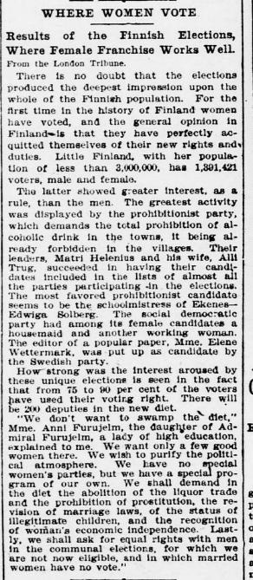

Evening star. [volume] (Washington, D.C.), 08 Aug. 1907. Chronicling America: Historic American Newspapers. Lib. of Congress.

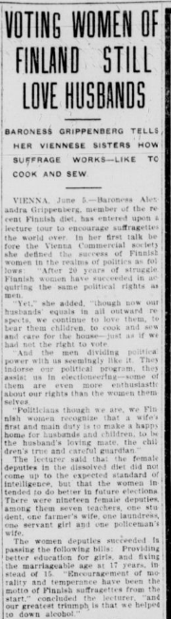
The Detroit times. [volume] (Detroit, Mich.), 05 June 1908. Chronicling America: Historic American Newspapers. Lib. of Congress.

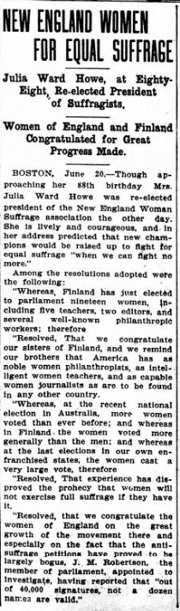The labor world. [volume] (Duluth, Minn.), 22 June 1907. Chronicling America: Historic American Newspapers. Lib. of Congress.

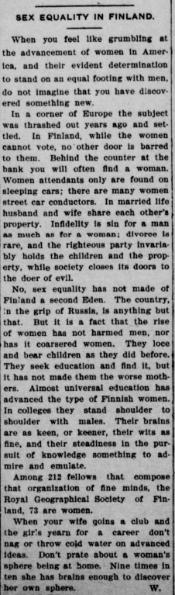Blue-grass blade. [volume] (Lexington, Ky.), 10 Sept. 1905. Chronicling America: Historic American Newspapers. Lib. of Congress.

